★ Lucky☆Channel ★
Category: Web | Difficulty: Hard

Description
Welcome to *Konata Izumi's Otaku Densetsu HQ* — a lovingly rebuilt early-2000s anime fan portal: tiled starfield, <marquee>s, 88×31 buttons, a hit counter stuck at a leet number, a guestbook, a webring, and a members-only Backstage. The staff swear the new session tokens are "very secure, RS256!" … but the intern left something on from the 2003 build. Two bugs stand between you and /flag.txt — and you'll have to chain them.
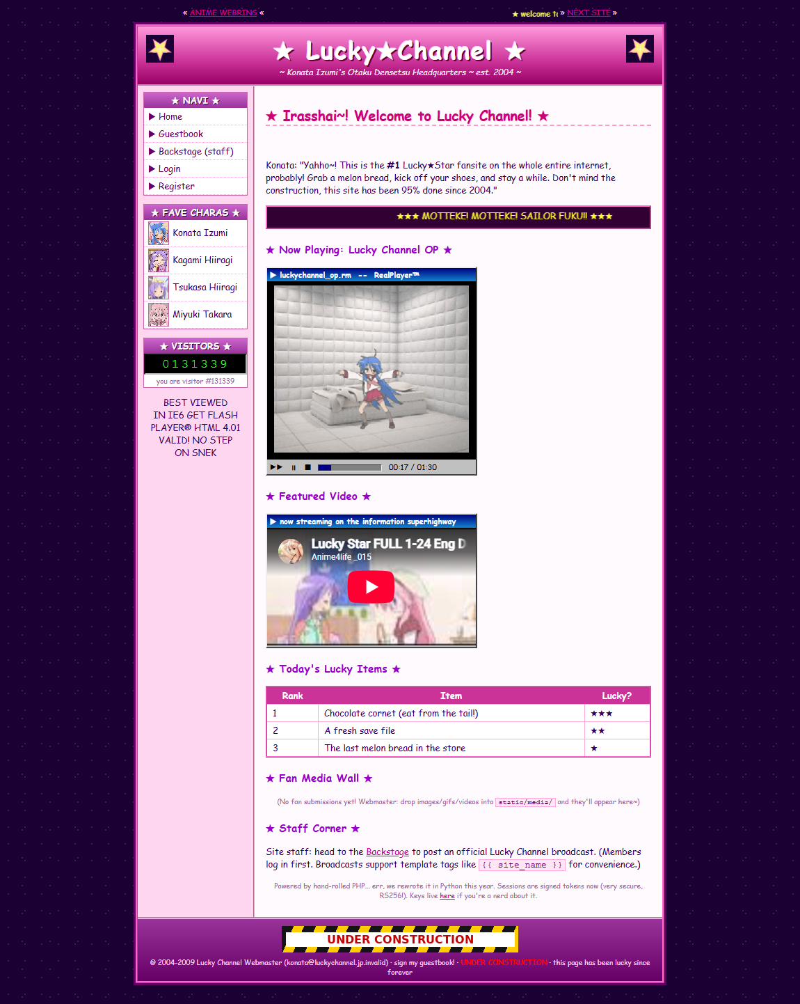
The Lucky Channel fan portal

Files
One hosted Docker container, built from challenge/. From that folder:
cd challenge
docker compose up -d --build # browse http://localhost:1337
Listens on port 1337, fully self-contained (no outbound network, no headless bot). The flag is set by the FLAG env var and written to /flag.txt at container start. Both bugs live in challenge/app.py (commented); the RS256 keypair is generated at build by challenge/gen_keys.py. Reference exploit: organizer/solve/solve.py; author writeup: organizer/SOLVE.md.

Hint(s)
- The home page brags "RS256!" and links the public key. Every page also carries an HTML comment: *"backstage still has the old HS compat path turned on from the 2003 build."*
- Stage 1 is a classic JWT algorithm-confusion: the legacy verifier accepts HS256 and uses the *public key* as the HMAC secret. The public key is published, so you can mint your own role=admin token.
- Stage 2: the admin broadcast preview is Jinja2 SSTI, but a blacklist blocks os, system, subprocess, eval, import, request, config, mro, subclasses, getattr, self, lipsum, attr( … It does not block the builtins route. Reach open through a Jinja global.

Walkthrough
Forge an admin session via a JWT RS256→HS256 confusion bug, then use the admin-only template preview for Jinja2 SSTI — bypassing the keyword blacklist by reaching builtins.open to read /flag.txt.
- Recon. GET /robots.txt disallows /backstage and /lucky-channel/pubkey. The home page says sessions are "signed tokens now (very secure, RS256!)" and links the public key; a page comment admits backstage still accepts the legacy HS path. Registering and logging in gives a lucky_token JWT with {"role":"user"} — and the backstage shows only a "regular member view," no broadcast box:
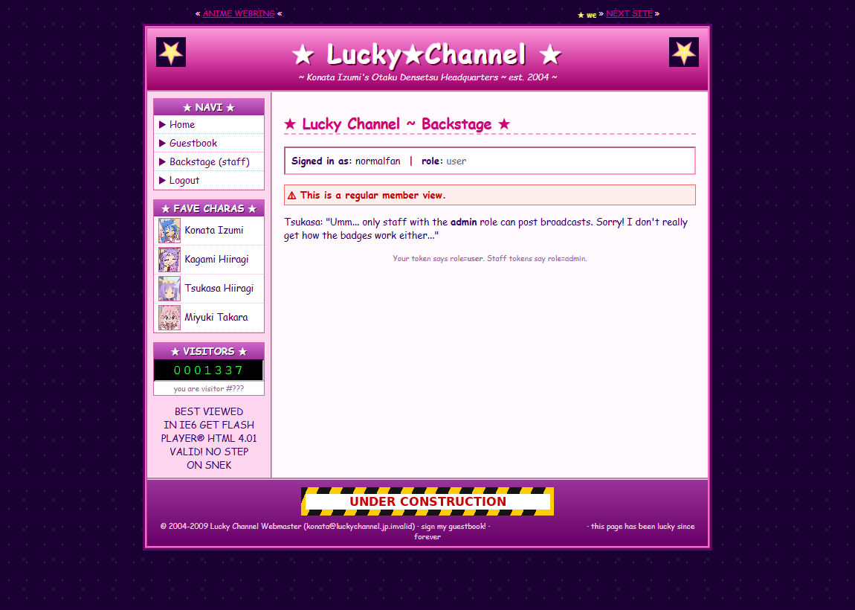
Backstage as a normal member — no broadcast box
- Stage 1 — JWT algorithm confusion → admin. Session JWTs are signed RS256, but /backstage's hand-rolled legacy verifier also accepts HS256 and computes the MAC using the public key PEM as the HMAC secret. Fetch the published key from /lucky-channel/pubkey, then forge a token with header {"alg":"HS256"} and payload {"role":"admin"}, signing with HMAC_SHA256(key=<pubkey bytes>, msg="<hdr>.<pay>").
- Become staff. Set the forged value as the lucky_token cookie and reload /backstage. The server now sees role=admin and the staff broadcast preview box appears:
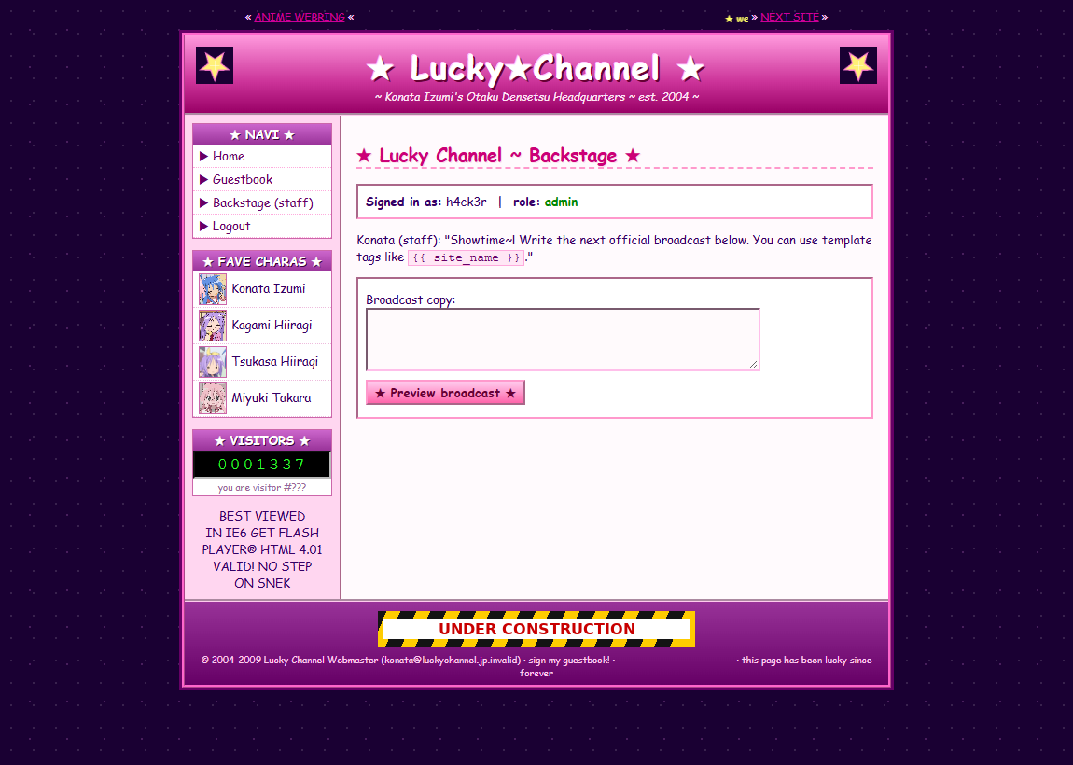
Forged admin token unlocks the broadcast box
- Stage 2 — SSTI past the blacklist → read the flag. The broadcast preview renders your input with render_template_string. The content filter blocks the usual RCE and gadget routes, but not the builtins route. Submit a payload that reaches open through a Jinja global:
```jinja
{{ cycler.__init__.__globals__.__builtins__.open("/flag.txt").read() }}
```
cycler is a built-in Jinja global; .__init__.__globals__ exposes the module globals containing __builtins__; none of the banned substrings appear. The rendered flag comes back in the preview pane:
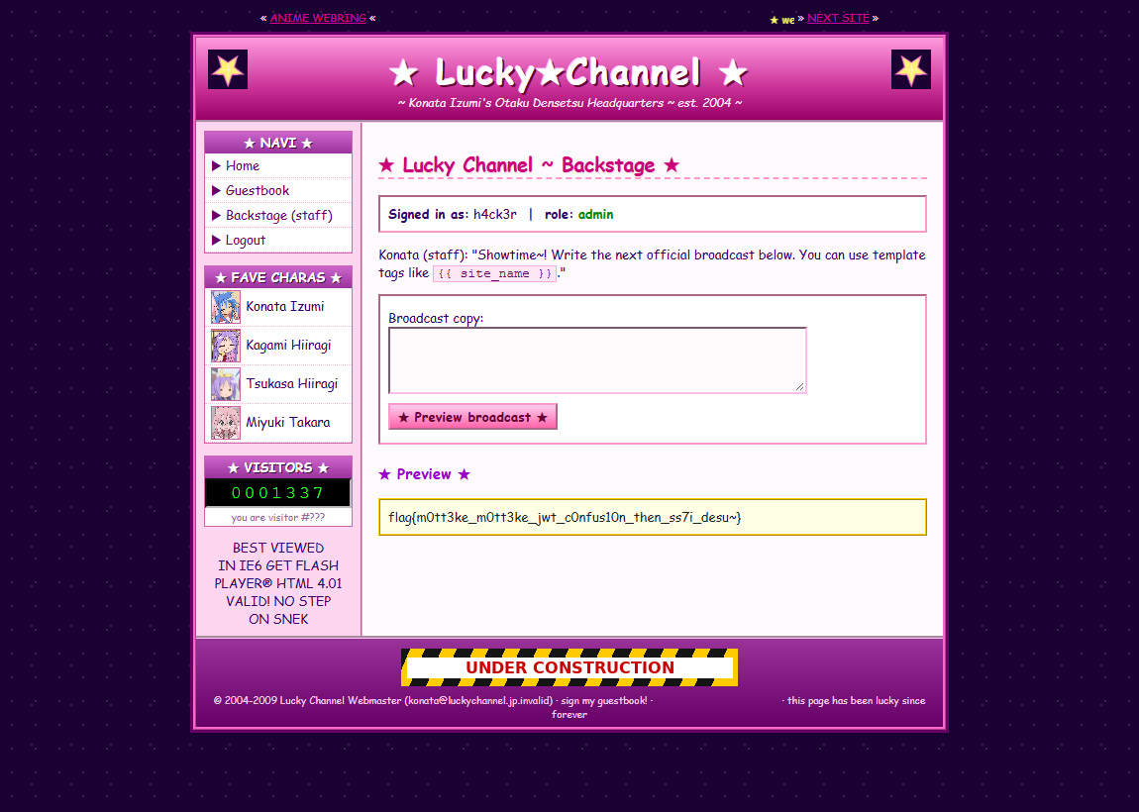
SSTI in the broadcast preview reads /flag.txt
The reference exploit performs the whole chain automatically:
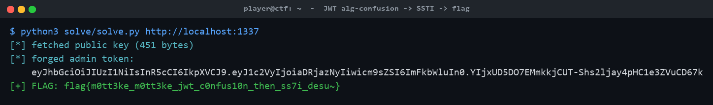
solve.py: alg-confusion → SSTI → flag
Red herrings: the guestbook auto-escapes (no XSS); the seeded konata:haruhi account is a plain member (you must forge the token); and os.popen-style RCE payloads stay blocked even as admin — just open() the file.

Flag
flag{m0tt3ke_m0tt3ke_jwt_c0nfus10n_then_ss7i_desu~}

